**Дата**: 21.11.2024

**Клас**: 9-А

**Предмет**: англійська мова

**Тема:** Навички роботи.

**Мета:** : формувати навички вживання лексичних одиниць по темі; удосконалювати навички читання, аудіювання й усного монологічного мовлення; розвивати пізнавальні інтереси учнів; виховувати інтерес до самостійного пошуку потрібної інформації, а також загальну культуру учнів.

**Вчитель**: Руда Д.В.

Хід уроку

1.Greeting

Good afternoon, guys! I’m glad to see you. Are you ready to start our

lesson? All set?

2. Wаrm up / Listening

Уважно слухати аудіо трек і дати відповідь на питання вчителя усно <https://learnenglishteens.britishcouncil.org/skills/listening/a2-listening/work> .

3. Speaking

At what age do people usually begin to work in your country?

At what age do people usually retire in your country?

At what age would you like to retire?

What do you think you will do after you retire?

How much money do you think you need to retire with your lifestyle?

Can you talk about what a typical day at your current job is like?

Can you describe some of the people that you work with?

Can you describe your current job?

What was your first job?

Do women usually work after they get married in your country?

Do you ever work overtime?

If so, do you get paid more for overtime work?

Do you have a part-time job? If so, what do you do?

Do you have to attend a lot of meetings for your job?

Do you have to do a lot of paperwork?

Do you have to work overtime?

If so, how often?

Do you have to work on Sundays?

Do you know someone who has worked as an undertaker?

What is the job of a an undertaker?

Can women do this job or is it better for a man to be an undertaker?

Do you like your boss? Why or why not?

Do you like your job?

Do you like your job? Why or why not?

Do you think it is more important to make a lot of money or to enjoy your job?

Do you think it's acceptable for women to be in the military? Why/why not?

Do you think people over 65 should be made to retire?

Do you think women and men should be paid the same for the same job?

4. Повторення

Повторення jobs :

<https://wordwall.net/uk/resource/2883889/jobs>

<https://wordwall.net/uk/resource/15504330/jobs-and-professions/jobs>

5. Writing

Виконати вправу подану нижче на закріплення словника , пов’язаного з професіями.

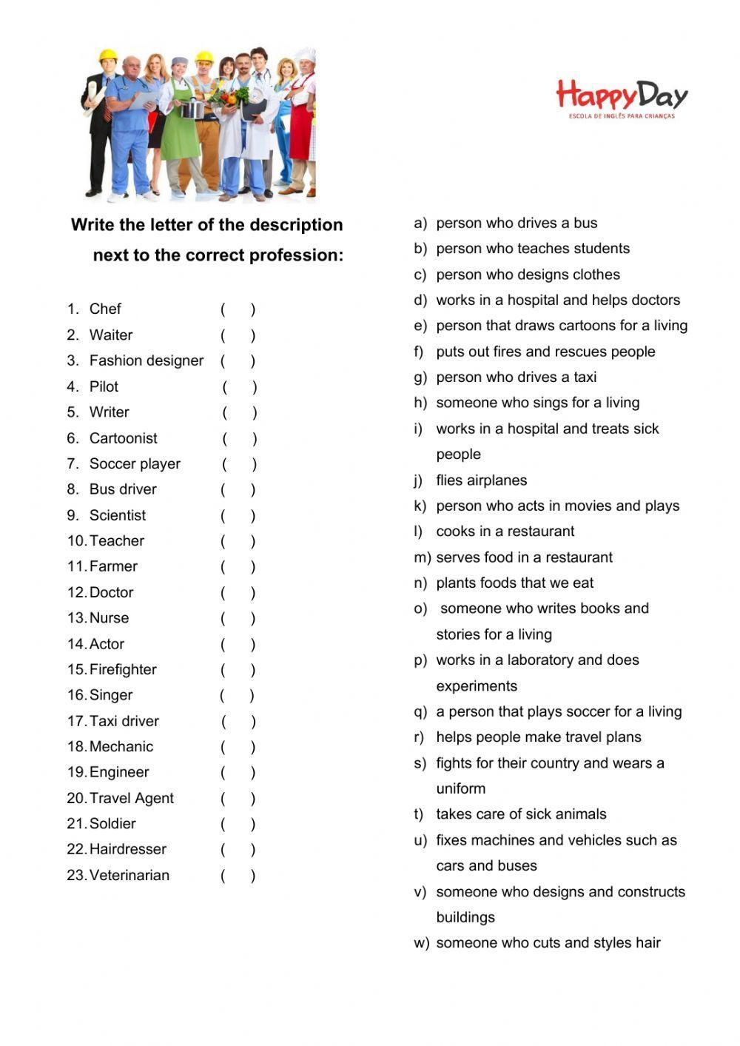

6. Homework

1. Виконати письмово вправу 4,5 стр 86-87.